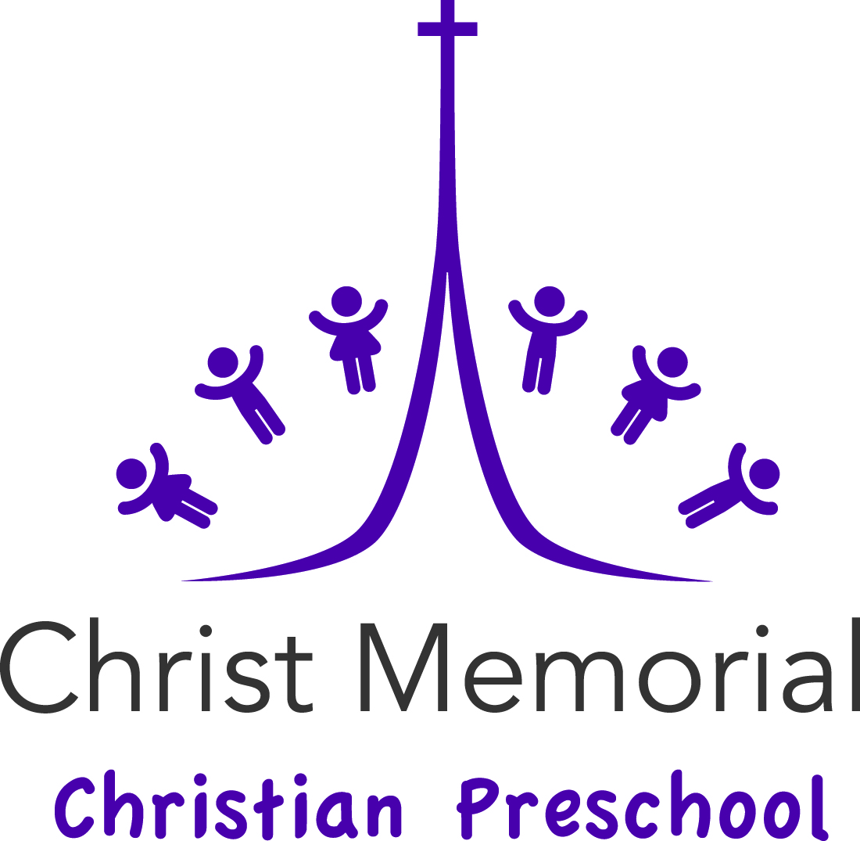

Parent Handbook

Point your children in the right direction ~
when they’re old they won’t be lost.
Proverbs 22:6

9/1/17

Section 1 – Welcome

1.1 History
Established in 1978, Christ Memorial Christian Preschool is a nonprofit preschool that is sponsored by the Christian Education Committee under the Session of Christ Memorial Presbyterian Church. The preschool is governed by the Preschool Board. The Preschool board consists of the Director, and a minimum of 4 other members representing various aspects of the church’s ministry. The board meets a minimum of 4 times a year to assure the school functions properly. The board may invite parents to serve as part of an advisory group for the purpose of gaining greater insight and suggestions for improvement.

1.2 Beliefs
At Christ Memorial Preschool
- We believe the Bible to be the inspired Word of God.
- We believe in the Triune God—Father, Son, and Holy Spirit.
- We believe in the Lord-Jesus Christ, the Son of God, and Savior of sinners, upon whom we rest alone for our salvation.
- We believe in the resurrection of the body and the life everlasting.

1.3 Mission
The mission of Christ Memorial Christian Preschool is to provide a developmentally age-appropriate program that promotes inclusive practices to meet the needs of children, families, and our staff. All children are welcome to attend Christ Memorial regardless of ability, need, background, culture, religion, gender, or economic circumstances whose parents/guardians agree to the teaching of their child according to the above Statements of Beliefs. Proverbs 22:6 illustrates our mission: “Point your children in the right direction-when they’re old they won’t be lost”.

1.4 Licensing
Christ Memorial Christian Preschool is licensed and regulated by the Maryland State Department of Education's Office of Child Care (OCC) under COMAR 13A.16 ("Licensed Child Care Centers"). Every year a resource specialist from the County will conduct an unannounced inspection during school hours. An announced inspection will occur every two years.

Section 2 - Registration and Enrollment

2.1 Registration
All children whose parents are in agreement with the teaching of the Statement of Beliefs are welcome to attend Christ Memorial Christian Preschool. Registration is held each February with current students having priority. Registration is complete when the registration form is completed, signed and the fee has been submitted. Registration fees are non-refundable. Refer to the preschool website for specific dates and times for registration.

2.2 Entrance Requirements
All children must be toilet trained before entrance is permitted.
- 2- day class on T & TH: Child must be age 3 by September 30th of the current school year.
- 3- day class on M,W, F: Child must by age 4 by September 30th of the current school year.
- 5-day class (M-F): This class is appropriate for those children who have preschool experience and will attend kindergarten the following school year.

2.3 Health Requirements
A completed medical form with proof of up to date immunizations for all children is required BEFORE the first day of class.This is a state requirement. The medical examination used to complete the form is to take place no sooner than twelve months prior to school's opening. If your child has any allergies that require the use of medication an allergy action plan and medication authorization plan must be filed with the school prior to entrance.

2.4 Inclusion
We strive to provide a quality program that includes children with disabilities or special health care needs. In accordance with the applicable federal and state laws we will make reasonable accommodations for a child with special needs. To this end we request that you share any written Individualized Education Program (IEP) or Individualized Family Service Plan (IFSP) with the school so that we can partner with you in providing the optimal learning experience for your child and give your child the best possible start for a successful future.

Section 3 - School Schedule

3.1 Calendar
School begins the week after Labor Day in September and ends on the last weekday before Memorial Day. unless otherwise noted. Since our schedule does not always align with Howard County Public School’s we publish a school calendar. The Preschool calendar can be used for planning and can be found on our website.

3.2 Hours
All morning sessions are from 9 a.m. to Noon. In the event there are afternoon sessions they will take place from 1 p.m. to 4 p.m.

3.3 Arrival and Dismissal
Children will arrive no more than five minutes before starting time. All children will be escorted to the classroom by a parent or guardian. Great effort should be made to ensure that children arrive on time as tardiness affects their preschool day.

Children are dismissed at Noon. Please wait for your child in the designated area for your class. Each child is dismissed individually. If someone other than the parent is picking up, please inform the teacher via a note
It is important that you are prompt in picking up your child. Children become distressed when not called for on time. If we are still on the playground at dismissal time please wait for your child inside the building.

3.4 Inclement Weather Policy
If Howard County Schools are closed due to weather, we are also closed. If HoCo. Schools are delayed for either 1 or 2 hours we will open at 10:30 and close at 12:30. It is not the Policy of the school to extend the school year due to inclement weather beyond our control. In the event of unusual weather the Preschool Board will reassess the policy.

3.5 Emergency Closings
You will be informed of other Emergency closings via email.

Section 4 - Financial Procedures

4.1 Registration Fee
A non-refundable fee is required to register your child in Christ Memorial Christian Preschool.

4.2 Tuition
Tuition is paid monthly by the 10th day of each month, unless other arrangements are made beforehand. Tuition can be paid by personal check, money order, credit card or ACH payment made payable to Christ Memorial Christian Preschool. Tuition may be put in the parent mailbox outside the director’s office or mailed to the school. A late fee of $10 is charged if tuition is not received by the 10th day of the month. Failure to pay tuition by the fifteenth day of the month is just cause for the Board to ask for removal of your child from the school. If your tuition check is returned for insufficient funds, you are responsible for reimbursement of any bank fees the Christ Memorial Christian Preschool incurs. A Family Discount of 10% off the total monthly family tuition is provided to families with more than one child attending our preschool.

4.3 Mid-month enrollment
Any child enrolled prior to the fifteenth of the month will pay the entire monthly tuition. If enrolled after the fifteenth of the month one half of the tuition is due for that month.

4.4 Withdrawal
There is no tuition refund for the current month of withdrawal unless it is an extenuating circumstance. Notification of withdrawal shall be in a written statement to the Director at least two weeks prior to withdrawal. The Director and the Preschool Board will consider refunds of tuition for extenuating circumstances on a per case basis.

4.5 Refunds for Illness
Tuition is not refunded for illnesses or temporary absences.

4.6 Fines
A Ten dollar fine for every five minutes for repeated failure to timely pick up your child will be imposed and will be paid directly to the teacher

4.7 Failure to comply
Failure to comply with the policies, procedures, or payment plan is sufficient cause for the Preschool Board to ask for withdrawal of your child from the school.
Section 5 - Health and Safety

5.1 Absences and Illness
If your child is absent please inform the school either by email or phone. If you know beforehand that your child will be out please provide a note.
Children with colds, fevers, or signs of contagious diseases are expected to remain home from school. The health department requires children to be fever free for 24 hours prior to returning to school. If a child has a contagious disease or is out of school for longer than three days, notify the Director, in the event other parents need to be informed. If during school a child develops a temperature or is complaining of not feeling well, we will notify the parent to have the child picked up.

5.2 Medications
Because we only have your child for three hours it is our policy not to distribute medications to children unless there is a life threatening situation (ex: EPI pens for food allergies or bee stings). Prior written permission from the child’s treating physician is required when medication is left at the school. Medication forms can be downloaded from our website.

5.3 Emergency Forms
Each child will have an emergency form on file. These forms are used to contact a parent or guardian in case of an emergency and also allow us to release your child to those contacts listed on the card. Therefore, it is important to keep the information current. Please inform the school immediately of any change in address or telephone numbers(s).

5.4 Nutrition and Physical Activity
Christ Memorial Christian Preschool focuses on good nutrition as well as healthy habits and therefore incorporates both into content areas, daily routines, and other planned learning experiences. Parents are encouraged to provide healthy snacks and are given a list of suggested healthy snacks. As part of our commitment to providing a Healthy and Active program we will not provide passive or interactive technology during the hours your child is at our program. As part of our commitment to providing a Healthy and Active program we will not provide passive or interactive technology during the hours your child is at our program. A copy of our Nutrition and Physical Activity Policy and a list of suggested healthy snacks can be found on our website.

5.5. Snacks
A snack and drink are served daily. Parents rotate providing snacks and drinks for the class. All snacks are to be sealed when brought to school. The teacher’s assistant will prepare the days snack in a safe and healthy manner. Snacks that are not sealed when brought to school must be returned to the student’s parent. As part of our goal to encourage healthy habits, snacks such as low fat milk, water, 100% fruit juice, celery, raisins, apples, crackers, etc. are strongly encouraged. A monthly schedule for snacks is posted prior to the beginning of the month. If you are unable to provide snack when it is your turn, please find a substitute.

5.6 Allergies
It is vitally important that the school is aware of any child with a food or other allergy. A list of children with allergies will be posted in each classroom and checked daily. If any classroom has a child with food allergies the teacher assistant will ensure that each monthly snack calendar lists the food and alerts parents that foods containing that ingredient will not be served (for example “ No Peanuts”). In addition the teacher assistant will check the list of ingredients of any food brought into the classroom to determine if it is safe for the child with the allergy. If it is not safe or if there is any doubt, the child will be given an alternative safe snack.

5.7 Child Protection Policy
Christ Memorial Presbyterian Church and the Preschool are committed to the safety, welfare, and protection of all our children. Our staff undergoes thorough background investigations as a condition of employment. In addition we are obligated by law to report any suspected cases of child abuse to Protective services.

5.8 School Security and Safety
Children’s safety is always a priority in school, on our playground and in the church parking lot.
We are always alert and aware of any potential dangers to students and take every precaution to ensure that their surroundings are safe and secure.

- Visitors are escorted at all times.
- Our building is locked from 9:30 am – 11:50 am every school day.
- We ask parents to report any suspicious activity to a staff member immediately.
- Younger children are not to be left in a car either at drop off or pick up.
- Always drive cautiously in our parking lot, especially during arrival and dismissal. Be aware of the appropriate entrance and exit signs in our parking lot.
- Our playground is inspected yearly and repairs are made whenever needed.
- During school children are supervised at all times while on the playground and obey the following rules
  - It is not okay to push or shove friends
  - It is not okay to run with sticks
  - It is not okay to throw mulch or remove mulch from the safety zone on the playground
  - It is not okay to walk up the sliding board
- After school hours you are always welcome to use the playground but please make sure your children are supervised and are following the playground rules.

5.9 Transporting Children
All students must be in appropriate car seats while traveling to and from field trips. All Parents who drive on our field trips must provide the school with a copy of their driver’s license as well as proof of automobile insurance. All students are to be well supervised on field trips. Teachers can transport students but only as a last resort.

5.10 Emergency Action Plan
Everyone hopes that they will never have to face a serious emergency, especially when caring for children. But such emergencies do happen. To prepare for emergencies and to safeguard our students an Emergency Action Plan has been formulated. The staff is trained in emergency preparedness, including CPR and First aid. In addition, the school is inspected yearly by the Fire Marshall and emergency evacuation drills take place monthly.

5.11 Insurance
Christ Memorial Presbyterian Church carries liability insurance that covers each child while attending school.

5.12 Smoke Free Environment
The preschool is committed to the health of our students and employee’s by maintaining a smoke-free environment to work, to play and to learn in; therefore, smoking is not permitted in or around the preschool and church.
.
5.13 Asbestos Management
In October 1986, the US Congress enacted the Asbestos Hazard Emergency Response Act (AHERA). Under this law, comprehensive regulations were developed to address asbestos in public and private elementary and secondary schools. These regulations require most schools to inspect for friable and non-friable asbestos, develop asbestos management plans that address asbestos hazards in school buildings, and implement response actions in a timely manner. These regulations assign schools many responsibilities. Our program for fulfilling these responsibilities is outlined in our asbestos management plan. The plan contains information on our inspections, re-inspection, response actions, and post-response action activities, including periodic surveillance activities that are planned or are in progress.

Section 6 - Staff

6.1 Philosophy
The staff members of Christ Memorial Christian Preschool agree that the following Biblical principles are their purpose for being at Christ Memorial Christian Preschool:
Deuteronomy 6:6-7—“Write these commandments that I’ve given you today on your hearts. Get them inside of you and then get them inside your children. Talk about them wherever you are, sitting at home or walking in the street; talk about them from the time you get up in the morning to when you fall into bed at night.
Matthew 28:19-20—“Go out and train everyone you meet, far and near, in this way of life, marking them by baptism in the threefold name: Father, Son, and Holy Spirit. ”

6.2 Selection and Members
The Director and Preschool Board select the staff of Christ Memorial Christian Preschool. Each staff member is expected to be of professed Christian Faith and have a strong Christian character. The guidelines of the Maryland State Department of Education are considered in selecting staff.

The staff at Christ Memorial Christian Preschool consists of
- Director
- Teachers
- Teacher Assistants
- Staff Assistant

Staff members set yearly program and professional goals through self-evaluations. They meet with the Director to assess their progress and review evaluations. Parents may be asked to provide input into staff performance.

6.4 Ratios
Each classroom has a maximum staff/student ratio of 1:7½
.

Section 7 - Educational Program

7.1 Philosophy
The educational program of Christ Memorial Christian Preschool strives to prepare each child for life here on earth and teach him to see God’s word and will in all things. During all times of instruction and in all areas of learning, the children are made aware that God is our Creator and that Jesus came to save us from our sins. Many skills are taught with reference to Bible stories and the Bible and Biblical principles in general. We welcome children with all abilities and support them based on their needs. Through inclusive practices, we aim to reflect our wider community and promote positive attitudes with both the similarities and differences in each other. To achieve this, we actively engage with children, parents, and other organizations as appropriate. Our goal is to help children grow at their own rate, in all areas of development, and to help them make a smooth transition into kindergarten.

7.2 Curriculum
Using the MSDE approved Creative Curriculum ® allows each child to discover and explore his world. Using this curriculum to guide our lesson plans we include age-appropriate activities reflecting children’s interests and skills, address the developmental needs of each and every child; and include information from an Individualized Family Service or Education plan, if provided.

The areas of development that we address are:

Physical Development: We help each child develop and care for the body God give them, and to be strong and healthy through daily exercises, games and the teaching of good health habits. Through play and teacher directed activities children develop both fine and gross motor skills.

Social/Emotional Development: We encourage each child to develop the attitude that God has made man to love and be kind to one another. With this in mind the child develops a loving, sharing, and respectful attitude toward others. He also learns to cheerfully take responsibility for self and belongings. We assist each child in using his imagination, thinking creatively and adjusting to new situations. Children will learn to follow directions as well as class routines and rules.

Cognitive Development: Problem solving, logical, representational and symbolic thinking are areas of development in this realm. Each child grows at an individual pace in this area. We help each child develop his mind to its fullest through activities and instructional materials specifically designed for this purpose.

Language Development: We provide an fun and loving environment in which children learn to use words to express thoughts; understand and follow directions, identify letters, and participate orally.

Spiritual Development: One of our main goals is to familiarize each child with the teachings and words of the Bible. We hope to guide and direct her to be a good, practicing Christian in her daily life. There are spiritual teachings in all aspects of the basic program. In addition, our Pastor provides Bible time on a monthly basis

7.3 General content themes
We provide each child opportunities to interact with their peers in a developmentally appropriate environment that offers a balance of child initiated and teacher directed activities. In promoting the above areas of development as we explore the broad topics of
- God and Me
- God and My Family
- God and My Neighborhood and
- God and My World
.

7.4 Daily Schedule
Below is a typical daily schedule:

09:00-09:25: Free Play in Centers
09:30-09:40: Together Time/ Language Art Activities
09:40-10:40: Free Play in Centers/ Small Groups /Art Activities
10:40-10:45 Clean-up time
10:45-11:00: Large Motor Play Time
11:00-11:15 Circle Time/Stories/Songs/Movement
11:15-11:20: Bathroom and Hand washing
11:20-11:35 Snack Time
11:35-11:40: Clean-up and prepare for Outdoor activities.
11:40-11:55: Outdoor Activity Time
11:55-Noon: Show and Tell/Sharing
Noon: Dismissal

Other activities include : field trips, in-house programs; Bible Time with Pastor Scott for all classes; Monday Music Program.

7.5 Show and Tell
Each month specific theme items are requested for show and tell, which complement the units. All items brought to school are to be labeled with your child's name.

7.6 Field Trips and Special Programs
At Christ Memorial Christian Preschool we believe it is important that children have concrete experiences to enhance classroom learning. Therefore, we will periodically go on field trips and ask others to come into our school to share their knowledge. Parents are an integral part in scheduling these programs. We will also ask for parental assistance in driving to and from and chaperoning field trips. Because it is important to carefully supervise the children on field trips we cannot accommodate siblings.

7.7 Parental Involvement
Parents with special talents, skill, hobbies, etc., are encouraged to share them with us at any time. In addition we ask parents to share their jobs and family culture with us at specific times of the school year. We also need parents help in the operation of the school. Below are some opportunities where you can help. Please see the director if you have other talents or interests that you are willing to share.
- Directory Parent – a parent that will create a school directory during the first part of the year.
- Sewing Parent – a parent that will mend dress up clother and doll clothes as needed throughout the year.
- Preschool Handy Parent - makes repairs and keeps equipment in good order.
- Housekeeping Committee- washes smocks; doll clothes, small toys, and helps with periodic cleaning of rooms.
- Field Trip Coordinator- Based on input from teachers arranges field trips, demonstrations, speakers, and in-house programs as needed.
- Scholastic Book Parent- Collects book orders and distributes Scholastic Books.
- Music Parent – Shares their musical talents by conducting a music class

Parents are encouraged to observe classes during the school year. However, your child may act differently when you’re in the classroom.

7.8 Home-School Communications
Good communication between home and school is important. New ideas and constructive criticism are welcomed and valued. The Director is always available in person, by email or by phone to discuss any issues or concerns you may have about our school. Every month you will receive a preschool newsletter through mail chimp or if you prefer, a hard copy.

Daily Communication between each classroom teacher and the family is posted outside the classrooms each day. This information includes specific information about daily classroom activities.

A Parent Orientation night is held the Thursday before Labor Day, we also schedule Parent-teacher conferences in October and March during school hours. School will not be open on conference days.
If you need to speak with your child’s teacher at any time during the school year, please make arrangements to speak with his/her teacher either before or after school. The teachers cannot accept verbal messages. Please provide a written note. Finally, it is important not to discuss your child in front of him/her or in front of other parents.

7.9 Classroom Discipline
At CMCP we believe that discipline means helping children learn how to manage their relationships and environment by being proactive and using positive guidance. We do this through constructive, accepting, and affirming guidance using positive behavioral supports and practices. Children are told what to do rather than what not to do! Children, along with their teachers establish classroom expectations and rules. Throughout the day children are given reminders prior to transitions in order to assist them in developing time management skills. Natural consequences are used whenever possible. Children are given choices to help them make appropriate decisions. For example, if it is time to cleanup, and a child resists, the child will be given choices. Depending on the situation, some choices could be: the child may be given a choice to clean up later; work with the teacher or another child; pick up a certain number of items, given praise and then asked to pick up a few more items. We attempt to distract from negative behavior by redirecting children towards positive activities. An example of redirection is offering another activity when there is a conflict thereby assisting the child in learning self-reflection. Physical discipline methods will NEVER be used. A child may be physically restrained only if in danger of hurting him/herself or another child.

Section 8 - Clothing

8.1 Clothing/footwear/outerwear
Please dress your child in comfortable and washable clothing.

Croc’s, sandals, and flip flops are not permitted. These types of shoes can often get caught in play equipment.

Please have your child bring outside wear that is appropriate to the weather. We will go outside everyday weather permits when it is above 32ºF, it is not raining, and/or the ground is not wet or icy. Please label all jackets.

8.2 Change of Clothes
Accidents happen, so we ask that you bring a change of clothes (pants, shirt, socks, and underwear) for your child in a gallon Ziploc bag labeled with their name. Please remember to make changes to the spare set of clothes as your child grows or the weather changes.

8.3 School T-shirts
When your child first enters Christ Memorial Christian Preschool he/she will be given a school t-shirt. Your child can wear this t-shirt any time they want. We request that they also wear them on field trips. If your child outgrows the t-shirt we have larger sizes you can purchase.
Section 9 - Misc

9.1 Birthdays
Birthdays are recognized in a simple but appropriate manner. Store bought cupcakes or cookies may be brought to school; however, the teacher shall be notified in advance. You may want to present a book to the school. It will be shared on the birthday and then added to the school's library.

9.2 Cell Phones
We ask that parents refrain from talking on their cell phones when dropping off and picking up their child.

